Artist Recognition

from Audio Features of Songs

An attempt to analyze Million Song Dataset

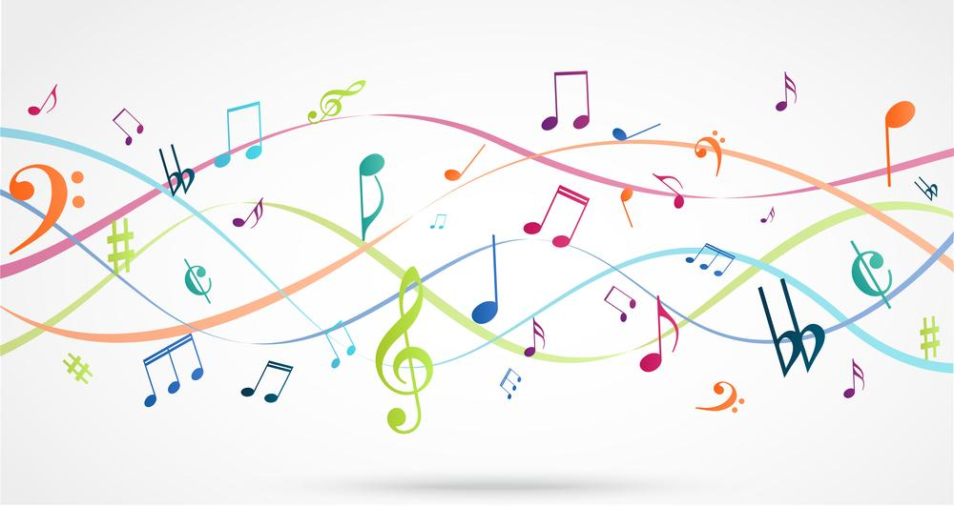

V 0.1 12.06.2015 Initial Draft

Project Team

Arulselvan Madhavan

Yogendra Miraje

Ameya Pandilwar

**Table of Contents**

**1** **Introduction**

**1.1** **Problem Statement**

**1.2** **Dataset Information**

**2** **Approach to solve the problem**

**2.1** **Data Preparation**

**2.2** **Applying Machine Learning**

**2.3** **Technology Stack**

**2.4** **Cloud Platform**

**3** **Solution**

**3.1** **Data Parsing and Loading**

**3.2** **Test and Train Data Preparation**

**3.3** **Modelling**

**3.4** **Evaluation**

**4** **Results**

**5** **Conclusion**

**References**

# Introduction

Science behind the music has been a topic of serious research recently. Analysing the huge data about songs and music composed for over a century is an exciting big-data topic and can provide some very interesting insights that have never been looked at before.

## Problem Statement

The primary goal of our project is to predict the Artist who composed the song by using the audio features of the song.

An Artist can be a person or a band of musicians who composed the song. A unique ArtistID identifies each Artist or a band. The dataset we are using is ‘Million Song dataset’ (MSD) that contains metadata about 1 million songs prepared through collaboration of Columbia University and The Echo Nest.

## Dataset Information

MSD has 273 GB of data comprising of 1 million songs/files(since 1922) from 44, 745 unique artists. The data is in HDF5 format.

The dataset has 42 fields for each song. You may find all the fields at <http://labrosa.ee.columbia.edu/millionsong/pages/example-track-description>

The fields for our analysis are given below.

|  |  |  |
| --- | --- | --- |
| **Column Name** | **DataType** | **Description** |
| Artist Id | String | ID of the Artist in the ECHO Nest database |
| Song Id | String | ID of the song in the ECHO Nest database |
| Timbre | 2D Array of Float | Texture fields of the song. |
| Year | int | The year in which the song was released. |

The timbre field is a vector that includes 12 unbounded values roughly centred around 0. Those values are high-level abstractions of the spectral surface, ordered by degree of importance. The first dimension represents the average loudness of the segment; second emphasizes brightness; third is more closely correlated to the flatness of a sound; fourth to sounds with a stronger attack; etc. After extraction of timbre data, we get 12 average values over the hundreds of segments of the song and 78 co-variances. We have added the released year of the song as a feature, Thus, for each song, we have 91[12 + 78+ 1] features.

# Approach to solve the problem

The first step towards analyzing the data is to store this data in some readable and understandable format. So, we parsed the complete dataset, extracted the key features required and loaded them into a distributed database. Having access to the key features in a distributed database enabled us to prepare our train and test data using Map Reduce. We chose a Multi-Class Machine Learning algorithm for training our model and predicting artists for the test songs. We prepared Confusion Matrix by year and used data visualization tools to analyze the variations in our predictions.

# 

# Technology Stack

1. Hadoop 2.6
2. Hbase 0.98.15
3. Anaconda Python 2.7
4. Thrift 0.9.3
5. Spark - 1.5.0
6. Scala 2.10

# Solution

## Data Cleansing

### Accessing the Dataset

The Dataset is available as an AWS Snapshot. We mounted the [AWS Snapshot](https://aws.amazon.com/datasets/million-song-dataset/) into a M3.xlarge EC2 machine, which served as our access point for data throughout our project.

### Reading HDF5 Formatted Files

Our Dataset was written in HDF5 format. Out of all high level programming languages, only Python had a well-written library for parsing HDF5 content. So, we decided to use Python to access the different features of the song.

### Feature Selection

The Key factor to the success of any prediction algorithm is feature selection. The Key audio feature for predicting the artists is timbre. Timbre is a 2D array of float values representing the spectral surface of the song. Given below is a sample timbre value for a song.

[[ 1.623 14.133 24.345 ..., 28.915 27.059 19.852]

[ 147.921 62.654 15.674 ..., 71.085 9.634 53.185]

[ -18.608 55.373 53.274 ..., -5.287 27.235 -49.148]

...,

[ 12.15 29.04 10.286 ..., -11.659 1.134 -23.767]

[ -17.023 26.954 2.878 ..., -9.901 1.608 -58.072]

[ -11.293 -20.522 -4.528 ..., 4.693 -2.655 1.341]]

There are 12 rows and hundreds of columns (1 column for each song segment1). We compute the average of each row and calculate the first 12 features. We compute the co-variance of this 2D array and calculate 78 features. And finally the last feature we choose is the ‘Release Year’ of the song. Given below is a sample feature vector for a song

SongID Timbre Year ArtistID

TRAQIED128F42915CC 47.0137585302 62.8697716535 2.07508530184 ……. -2.02984514436 -0.841545931759 -4.00789107612 1999 ARPFQSQ1187FB5284B

Segment1- a set of sound entities (typically under a second) each relatively uniform in timbre and harmony

### Loading Data Into HBase

Since we use Python for extracting the features and HBase is written in Java, we needed ‘Thrift’ to translate python objects into HBase rows and columns. We used a library called ‘HappyBase’ to create HBase connection via thrift and post data to the thrift server.

### Map Reduce Jobs

**Mapper**

Input1: HDF5 File Location(Files Containing Song)

Input2: Thrift Server IP address and Port

**Map Only Job using Map Partitions**

We managed our database connections by using Map Partitions and specifying the number of partitions.

The entire input files were split into x partitions and each partition established a connection with Hbase and re-used that connection for all the records that were sent to that partition.

# Test and Train Data Preparation

## Filtering the Data

### By Year

One of the features that we use for predicting the artist is the year in which the song was released. The Dataset did not have ‘release year’ for some songs. As a first step, we filtered all the songs that had no information about their ‘release year’.

### By Artists With more than 50 songs

In Supervised learning, the most important factor for building a good prediction model is choosing the data on which the model will get trained. We decided to train our model with artists who has more than 50 songs. We filtered out the artists who did not have more than 50 songs in the dataset.

### Map Reduce Jobs

**Mapper**

Input1: HBase IP address and Port

Input2: HBase Table Name

Task

Task: Scan entire HBase Table

**Mapper Side Filter**

Filter Songs which don’t have information about release year.

**Mapper Output Format:** (ArtistID, (SongId,Year))

Key: ArtistID

Value: (SongId,Year)

**Reducer**

Key: (ArtistID,[(SongId,Year),(SongId,Year)...]

**Reduce Side Filter**

Filter Artists who don’t have more than 50 songs.

**Task**

For each artist who have more than 50 songs and for each song that belong to this artist, get the row from HBase.

The last 5 songs of the artists go to the Test Dataset.

All the remaining songs goto the training dataset.

**Reducer Output Format (LibSVM Format)**

ArtistID 1:Feature1,2:Feature2...90:Feature3,91:Year

# Applying the Machine Learning Algorithm

## Deciding the ML Algorithm

Since we needed to do multi-class prediction, we needed a Multi-Class ML algorithm that trains well on distributed machines. After considering KNN, PCA and Naive Bayes, we decided that Logistic Regression best fits our needs.

## Training and Testing the dataset

We used the Logistic Regression that comes as part of Apache Spark’s MLLib library. We tried training our model in different AWS machines. Below are their runtimes.

# Analysis of Prediction Results

## Confusion Matrix By Year

We decided to do a confusion matrix by year to analyze if there have been any significant correlation between the timbre vectors(produced by old musical instruments) in the 1920s to 1980s vs 1990s to 2010s(modern musical instruments). We found out that our model performed equally well on old songs and new songs.

ToDo: Add accuracy stats and graphs here

## Predictability of Artists

In order to evaluate the predictability of artists with our model, we found out the artists who were predicted most accurately and also those who were totally unpredictable. This may give us some of the insights about the artists who are producing songs of similar type and who are producing varying kind of music.

### Most Predictable Artists

Below are the some of the artists that were predicted with 100% accuracy in our tests:

ARYF20K1187B9B76BD: George Lopez   
ARQJR4T1187FB3D259: Yonder Mountain String Band  
ARMGO6W1187FB3CEB9: Down to the Bone

### Least Predictable Artists

Below are the some of the artists that we could not predict accurately even for once:

ARIGI7G1187B9A6D83: Jimmy LaFave  
ARFN3551187FB4C930: The Turtles  
ARLVX371187B9AF852: Peter Dennis Blandford Townshend

# Performance

Below is the performance comparison for running our machine learning algorithm on AWS with different configuration.

|  |  |  |  |
| --- | --- | --- | --- |
| **No.** | **Instance Type** | **Configuration** | **Run time** |
| 1 | m3.xlarge | 1 Master, 2 Core | 2 hour, 39 minutes |
| 2 | m3.xlarge | 1 Master, 5 Core | 1 hour, 17 minutes |
| 3 | m3.xlarge | 1 Master, 10 Core | 1 hour, 18 minutes |

# References